Singleton Pattern

* Creational pattern
* Having only one object of a class



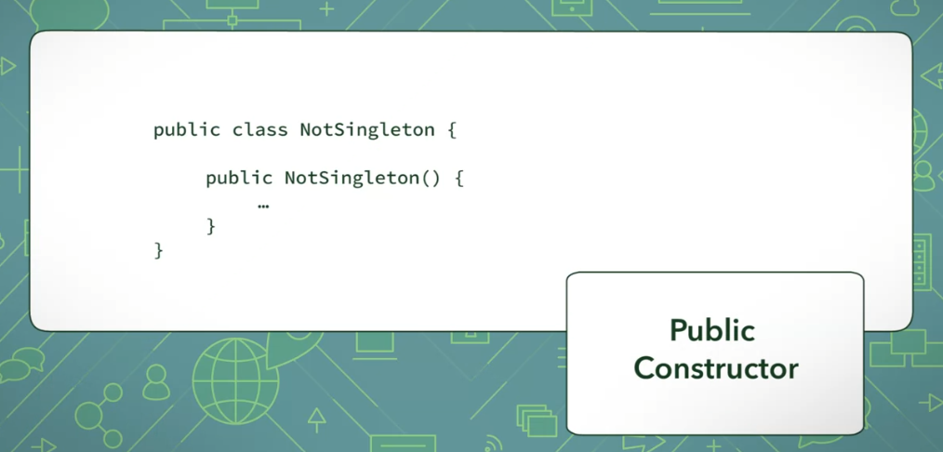

Create a private instantiation

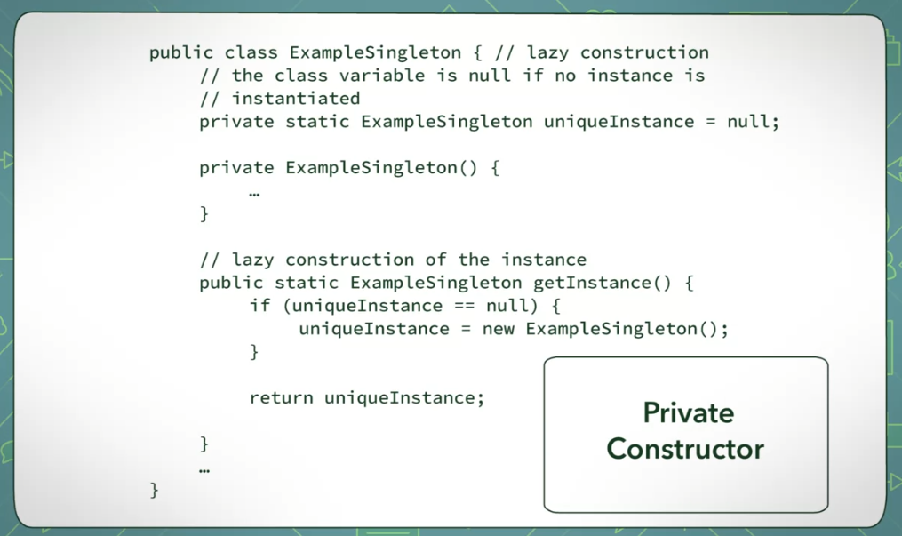



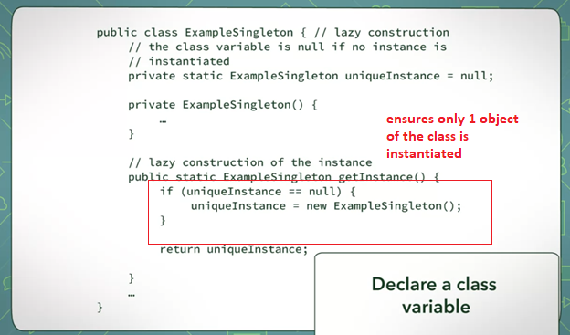



* Not created until it is needed
  + In our example, it is only instantiated when you getInstance()